2026 Summer - Free - Youth Golf Camps
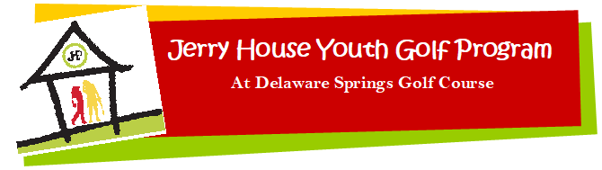
The registration fee is paid by The Jerry House Youth Golf Association (501c3)
Group golf lessons for kids between 6 & 18 years old
***The summer of 2026 will have three camp sessions ***
Session 1 - June 22 – 26th
Session 2 - July 20 – 24th
Session 3 - August 3 – 7th
Classes are 1 hour each day between 8 am and 12 pm. Times are scheduled by age groups.
The classes teach golf fundamentals

Grip Full Swing Putting
Stance Golf Course Etiquette Short Game
________________________________________________________________________________
REGISTRATION FORM
Youth name: _________________________________________ Age: _________________
Parent/Guardian Name: ___________________________________________________________
Telephone: ___________________________________________________________
Address: ____________________________________________________________
Email: ____________________________________________________________
Best way to contact you: ______ email ______ text ______ mail

T-shirt size: adult or youth SM MED LG XLG Do you need clubs? Yes or No
Please circle which session you would prefer:
Session 1: June 22 – 26th Session 2: July 20 – 24th Session 3: August 3 – 7th

Drop this form off at the Delaware Springs Golf Course Pro Shop, give to your golf coach or call us!

For more information: Call 512-756-8471

